Competitor’s reference

Main one’s that we reference with

<https://www.ninjavan.co/en-sg/>

<https://www.gogovan.sg/>

<https://www.lalamove.com/sg-eng/business-home>

<http://www.detrack.com/>

<https://versafleet.co/>

Smaller companies

* Zap delivery
* Roadbull
* Zyllem
* Fast fast
* Carpal

Some background information about CrossTrack

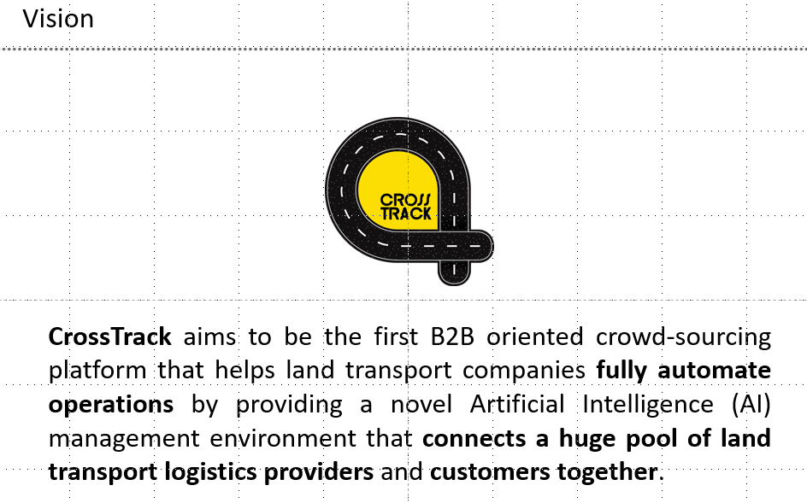

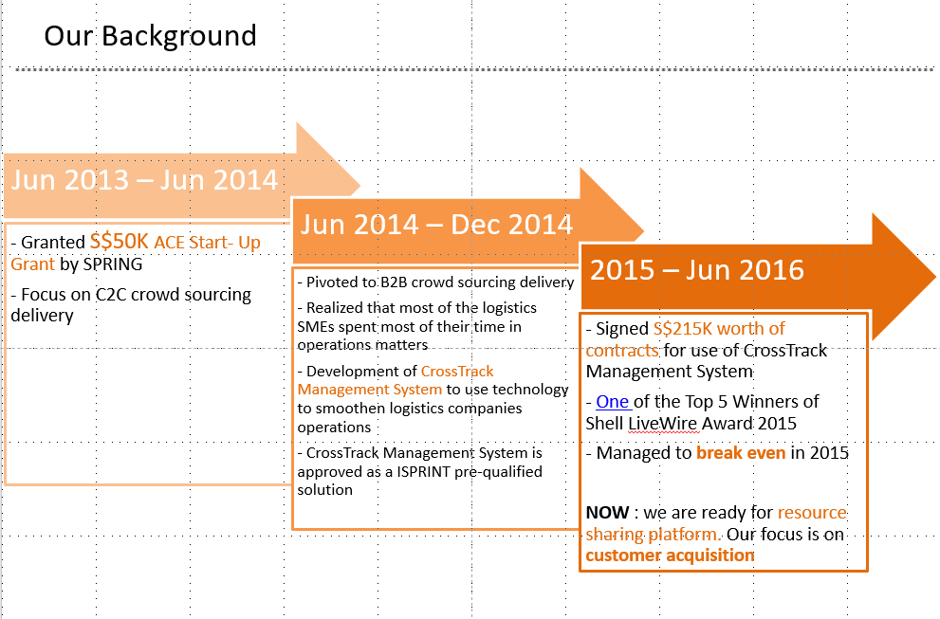

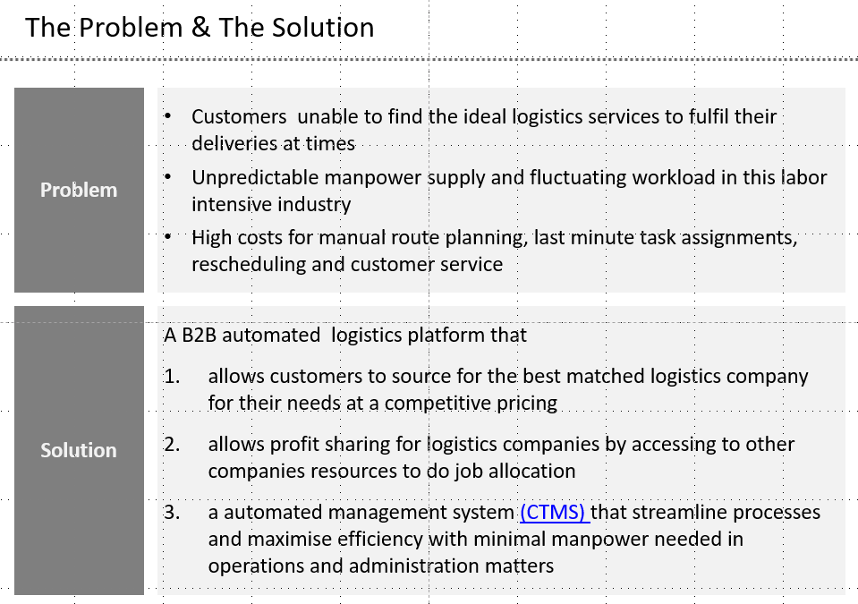

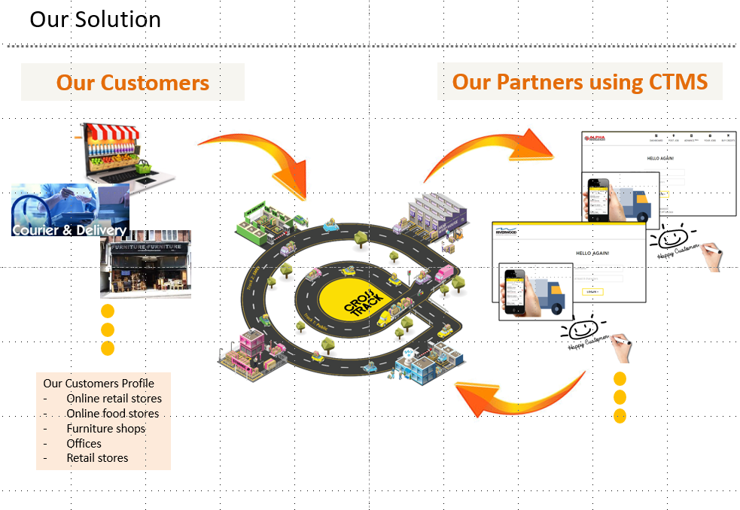

Content write up for Crosstrack.sg

Main Page (*Had written few ways but not sure which will flow, need your help on this)*

Source for the best matched logistics provider to fulfil your requirements!

**Reliable** | Partnering with Reputable Logistics Providers | Trustworthy | **Partnering with Established Logistics Providers** | **Dependable Delivery Partner for You** | Timeliness | Deliver with Promise | Reasonable Pricing | Competitive Pricing | Seamless Delivery through Automation | Automated Delivery Request | Automated Logistics Solutions | Request, Track and Complete your Delivery through Technology | Tracking of Deliveries using Technology | Transparent

Unparalleled Reliability

Connecting You With Reputed Logistics Providers

Cutting Edge Technology

*(My boss selected the 3 key points but it sounds the same for me.. what do you think? )*

*(Not too sure which ways is better to capture reader’s attention)*

At CrossTrack, your business is our business.

We help facilitate your business growth, eliminate possible downtime and maintain long-term sustainability through advanced technology and connecting you with industry’s best logistics providers.

(Button 1) **Start Shipping** *(link to http://control.crosstrack.sg/new_signup/)*

(Button 2) **Request a Quote** *(link to contact us page)*

We’ll get in touch within 1 hour* of request

(Button 3) Track your Order

*During office hours

Customers Logos *(to be provided by CT)*

Partners Logos *(to be provided by CT)*

**Get in Touch!** *(refer to Charles Schwab* [*Contact Us*](https://www.schwab.com/public/schwab/client_home/contact_us) *page as reference on the layout)*

**Find Us**

*(To show a map of our location)*

2 Jalan Rajah #05-24   
Golden Wall Flatted Factory   
Singapore 329134   
  
**T :** +65 635 44 635   
**E :** [info@crosstrack.sg](mailto:info@crosstrack.sg)

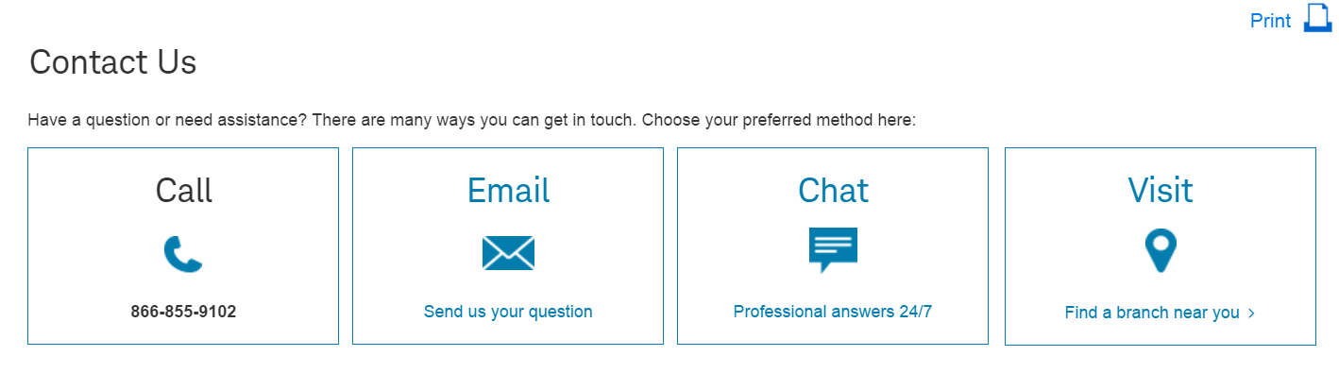

*Change the icon and link the email to info@crosstrack.sg*

Ask for A Quote

Business Enquiry

*Email link to info@crosstrack.sg*

635 44 635

Customer Enquiry:

Name:

Company (optional):

Email Address:

Contact Number (optional):

Your Message *(any max numbers?)*:

Business Enquiry:

Name:

Company:

Email Address:

Contact Number:

Industry:

How did you know about CrossTrack?

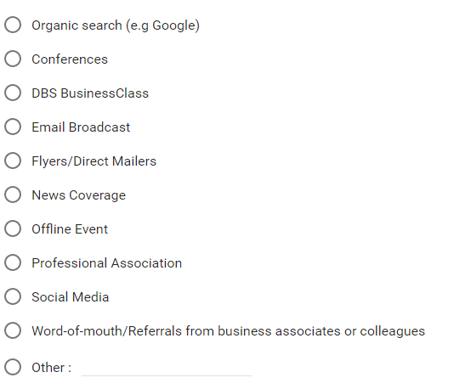

Let us know your Delivery Requirements *(all questions are compulsory):*

1. Type of Delivery
   1. Ad Hoc (Minimum 5 deliveries per week)
   2. Scheduled (Fixed amount of deliveries)
   3. Others:
2. Description of item(s) to be delivered (Eg. Clothes, Electronics, Perishables etc)

*(free text up to 200 words)*

1. Any special requirements?
2. *(free text up to 200 words)*

**Let Us Help You!**

Congratulations! With your enterprising spirit, you have just successfully set up your e-commerce store. Whether you are retailing the latest fashion apparels or other amazing products, you need to get one of the largest aspects of your business in place - Logistics.

Achieve more with less. By simplifying the purchasing process, you can empower your customers to make their purchases anytime, anywhere.

In this rapidly growing Age of the Customer, 88% of consumers have been influenced by an online customer service review when making a buying decision. With the risks of negative feedbacks spreading like wildfire, the least you want is having your hard earned reputation ruined by low-quality delivery services from your logistics partner.

Let us free up the time and burden for you!

=================================================

Frustrated with documents / parcel lost or unable to reach your customers on time?

Customers bugging you with endless questions on their pending deliveries?

Unable to find a reliable delivery service that tailors to your unique requirements?

Let us help you with the tedious delivery matters - so you can focus more on your core business functions.

**How can you benefit from our services?**

**Deliver to Your Customers’ Door Step with Our Trustworthy Partners’ Services**

Expect impeccable deliveries by our partners who attend to all your delivery needs.

**Bespoke Customer-Centric Support Team**

Spend more time growing your business by entrusting the responsibilities of arranging delivery schedules with your customers to us. Our excellent customer service team places your customers’ needs on top priority.

**Enjoy a Seamless Experience with our State-of-the-Art Technology**

Manage your deliveries effortlessly via our automated platform. You can submit new delivery requests, track your shipment status and view e-signatures through our online portal.

(Button 1) Set Up An Account *(link to http://control.crosstrack.sg/new_signup/)*

(Button 2) Request a Quote *(link to contact us page)*

You will hear from us within 1 hour* of request

(Button 3) Track your Order

Partner with Us

Ready to expand your fleet of drivers but tied down with exhausting daily operations?

Do you have customers constantly ringing you up to check on their delivery status and disrupting your work?

Are you working day and night by merely managing requests, scheduling drivers, handling manual invoices and many other minuscule issues that demand for immediate attention?

You have pending jobs from your customers that you are unable to fulfil, yet feel too guilty to reject?

If you have answered 'Yes' to any of the questions above, we are excited to present an all-in-one platform that caters to every aspect of your operational, financial and customer service needs - our sophisticated CrossTrack Management System.

**3 Reasons Why You Need to Automate Your Operations Needs**

**Billing and Tracking of Invoices**

There will be moments when you are tired of doing reconciliations or constantly monitor the payment status for the past months’ invoices. Let our system file and organise these invoices for you automatically and meticulously. View the outstanding invoices on each customer’s profile at a glance and resend the invoices to them with a click of the button, if required.

**Live Tracking of Delivery Status**

Receiving a live status update of the delivery is only a click away. Find out if your driver had completed their assigned jobs or if traffic conditions are holding up the deliveries. Checking on the drivers’ status is now much safer than spamming calls, SMSes or whatsapp messages to your drivers while they are driving.

**Route Optimization for Your Drivers**

Having all of Singapore’s routes at the back of your mind requires years of driving experience and knowledge of the new roads or amendments. With our advanced GPS system, you can help your drivers map out their various routes in the most efficient manner.

*(use any of the banners in this page and link the banners to:* <http://www.ida.gov.sg/Collaboration-and-Initiatives/Initiatives/Store/iSPRINT-Packaged-Solutions>*)*

cid:320BB0F24719574FAA3AC9F77A07931A@resoe.gov.sg





(Button 1) Contact Us Now *(link to contact us page)*

(Button 2) Government Grants Available for You

Government Grants Available for You

**1.iSPRINT Packaged Solutions**

CrossTrack is pre-qualified as a Logistics Management System Provider under the Sector (Scale Up) iSPRINT Program. Under this 2-year subscription program, you only need to pay 30% upfront to us and we will work out the remaining balance directly with IMDA.

Eligibility

Your business must meet the following requirements to qualify for iSPRINT.

1. You are a local SME with
   * Company registered or incorporated in Singapore
   * Minimum 30% local shareholding AND
   * Company's Group annual sales turnover not exceeding S$100 million OR  
     Company's Group employment size not exceeding 200 workers
2. You do not already own / use any other solutions that you will be adopting (i.e. accounting, payroll or POS solution).

Our Package Information:

Packaged Pricing range from S$5,000 to S$50,000

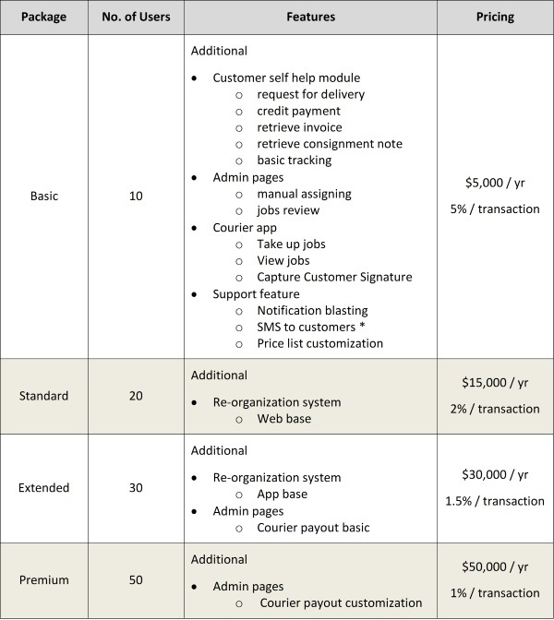   
** SMS charges are not included in the package pricing. Each SMS sent is charged at S$0.10 .

Included Services  
Each of the packages above includes the following professional services:  
a) Consultation Service:  
    i. Logistic Operation Consultation (Basic) - 1 session  
b) Training Services:  
    i. Staff Training - 1 session  
    ii. Software Training - 1 session

**Optional Items**  
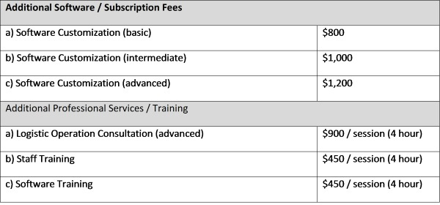

**2.Productivity Innovation Credit (PIC) Grant**

SMEs can keep abreast of their competition and increase their operations efficiency through Government Funded Grants and Schemes. The Productivity and Innovation Credit Scheme (PIC) is a straightforward grant, which can be used to implement cutting edge digital solutions to improve business productivity.

Each SME can apply for a 40% cashback for the implementation of productivity solutions.

Eligibility

To be eligible for the cash payout option, you must have:

* Incurred the mandatory qualifying expenditure during the basis periods for YAs 2011 - 2015
* Employed at least 3 local employees (Singapore Citizens or Permanent Residents with CPF contributions)
* Active business operations in Singapore

Our Story **(NO NEED VETTING, THANKS!)**

Frequently Asked Questions *(from your perspective, do you think can help me to increase the questions? Thanks!)*

1. **Do you offer a standard pricing structure?**

For Ad Hoc jobs, you may refer to our pricing guide that is available after an account had been registered. If you have any special requirements, feel free to call us directly at 635 44 635 or shoot an email to [info@crosstrack.sg](mailto:info@crosstrack.sg) (we will normally get back to you within the next 2 hours.)

1. **How do I post jobs?**

Register for an account with us, and once your account is activated, you will be able to post your job under ‘Post Job’ tab.

1. **Your stated pricing is out of my budget. Is there any way we can discuss about the pricing?**

Our state pricing is fixed at the moment. However if you have a large volume of deliveries to be made, or an alternative proposal, do give us a call at 635 44 635 or drop us an mail at [info@crosstrack.sg](mailto:info@crosstrack.sg) and we will get back to you within the next 2 hours.

Privacy Policy **(NO NEED VETTING, THANKS!)**

Refer to http://control.crosstrack.sg/privacy_policy/ for the information

Terms of Use **(NO NEED VETTING, THANKS!)**

Refer to http://control.crosstrack.sg/terms_of_use/ for the write up

Stay in the Loop **(this will be where we put the articles)**

Keywords:

Delivery

Delivery service

Delivery in Singapore

Delivery service in Singapore

Courier service

Urgent delivery

Express delivery

Courier in Singapore